Proposal #1
Drop game
Short big picture description : A block (Player) drops down from a platform with a small opening at the top of the screen. Platforms with different sizes move across the screen from the left and right, if the player touches the sides of the platforms or is pushed by it the game ends, if the player manages to land on top of the platform for a few seconds and continue dropping downwards, the game continues and they gain a point every platform they pass. When the player reaches the bottom the screen moves upwards and the bottom platform becomes the new top platform where the player starts again. Newly generated platforms move across the screen from both sides once again. Player keeps previous score and another score increases by 1 representing the total levels passed.
Sketch of canvas:

Features: Randomly generated platforms, Scoreboard,
Hurdles: The Collision code, moving the screen upwards, making there is a successful path for each level of randomly generated platforms.

Major Coding Concepts and Techniques
• Classes and Objects – To represent the Player, Platform, and perhaps a GameManager for structure.
• Arrays or ArrayLists – To store multiple platform objects and handle adding/removing them as the game scrolls.
• Timers or Frame Counting – For things like waiting a few seconds on a platform before allowing the player to fall again.
• Collision Detection – Checking overlaps between rectangles (player vs platform).
• Random Generation – To create platforms of random widths, positions, or movement directions.
• Coordinate Transformations – Adjusting all object positions when the screen scrolls upward.
• Image and Text Rendering – Using PImage for graphics or shapes (rect(), ellipse(), etc.) for simpler visuals; text() for displaying score.
• State Management – Handling game states like “start screen,” “playing,” “game over.”
Trickiest Concepts
• Collision Detection Logic
- Especially differentiating “standing on top of” vs “hitting the side.”
- Requires careful bounding-box math and correct order of updates.
• Platform Scrolling and Re-Creation
- When the player reaches the bottom and everything scrolls upward, you’ll need to manage existing platforms and spawn new ones.
- This involves coordinate shifts and keeping track of what’s “off-screen.”
Game Timing and Physics
- Handling gravity, player velocity, and motion smoothing.
- Making movement feel right takes experimentation.
- Game State Resetting
  - When restarting or leveling up, keeping scores and resetting positions cleanly.
Game State Resetting
  - When restarting or leveling up, keeping scores and resetting positions cleanly.
Ordered list

Phase 1 – Player & Basic Gravity
- Draw a rectangle for the player.
- Add y velocity and acceleration (gravity).
- Allow horizontal movement (left/right) via keys.
- Prevent player from falling off the bottom of the screen.

Phase 2 – Add a Single Platform
- Create one static platform rectangle.
- Detect collision with the platform’s top (stop falling when landing on it).
- Make sure side and bottom collisions are handled (simple bounce or game over).
Phase 3 – Platform Movement
- Give the platform horizontal movement (left → right → left, etc.).
- Detect side collisions with the player (game over if touched).

Phase 4 – Multiple Platforms
- Create a Platform class.
- Use an ArrayList<Platform> to hold several moving platforms.
- Update and draw all platforms in a loop.
- Randomize platform widths, heights, and speed.

Phase 5 – Scoring and Timing
- When player lands on a platform, start a timer (using millis() or frame count).
- If the player stays long enough, award 1 point and allow them to drop to the next one.

Phase 6 – Scrolling & Level Progression
- When the player reaches the bottom, move the screen up (shift all platforms’ y values).
- Generate a new set of platforms at the top for the next level.
- Keep track of both score and level counters.

Phase 7 – Game States and Restart
- Add states: start, playing, gameOver.
- Show text screens for start and game over.
- Allow restarting the game (reset variables).

Phase 8 – Polish and Extras (Optional)
- Add PImages for player and platforms.
- Add sound effects or background music.
- Add difficulty progression (faster, smaller platforms).
- Add visual effects (camera shake, particle effects, etc.).
11/4
Goals for the day:
Create the rectangle using x and y variables for the player and add movement for with WASD using keypressed. Stop the player from moving off the screen in all four directions using if statements. Make a gravity and velocity code for the player when jumping and moving.
Things I accomplished:Finished adding rectangle and movement and preventing player from moving off screen.
Things I need to do next class:Make gravity and velocity code for player when jumping and moving and create a platform.
11/6
Goals for the day:Create a class for the player and add gravity and velocity code to it. Create a single platform
Things I accomplished:
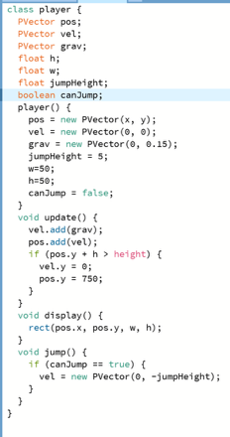
Created class and gravity and velocity code for player
Things I need to do next class:Finish coding movements and create a platform with collision code
11/10
Goals for the day:Create a starting platform with collision code that stops player from falling through
Things I accomplished: Created starting platfrom class and collision code with player that stops the player fromfalling through when it is at the top.
Things I need to do next class: Create class and movement for lower platforms and arraylist if I have time.
11/12
Goals for the day: Create class and movement code for lower platforms and arraylist if I have time.
Things I accomplished: created class and movement for lower platforms and arraylist for it.
Things I need to do next class: Fine tune collision code and make sure arraylist platforms don’t overla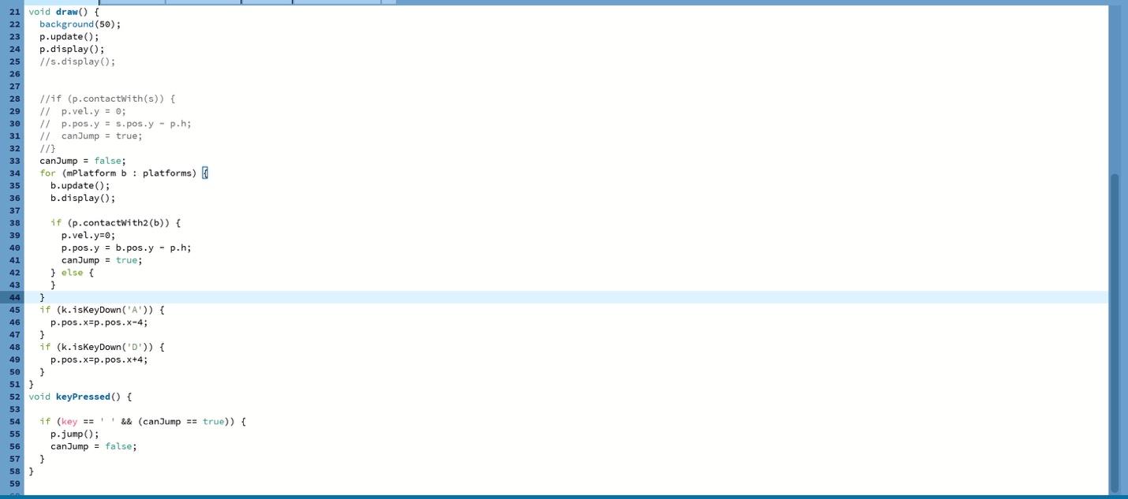p
11/14
Goals for today: Fine tune collision code and make sure arraylist platforms don’t overlap
Things I accomplished: Did not finish goals.
Things I need to do next class: Finish goals from 11/14 and create a better collision code.
11/18
Goals for today: Finish making non-overlapping arraylist platforms and create a better collision code.
Things I accomplished: Finished making non-overlapping arraylist platforms
Current Progress: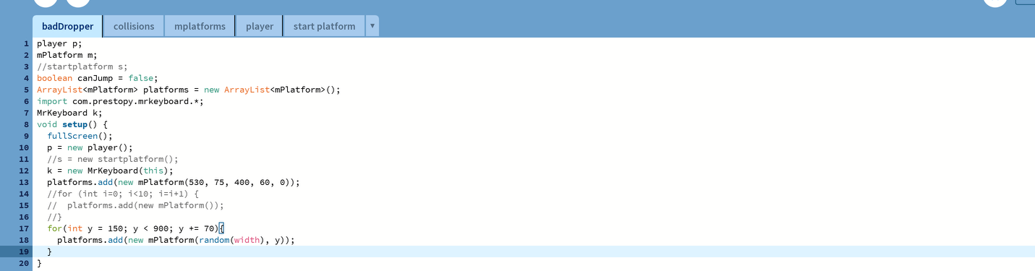
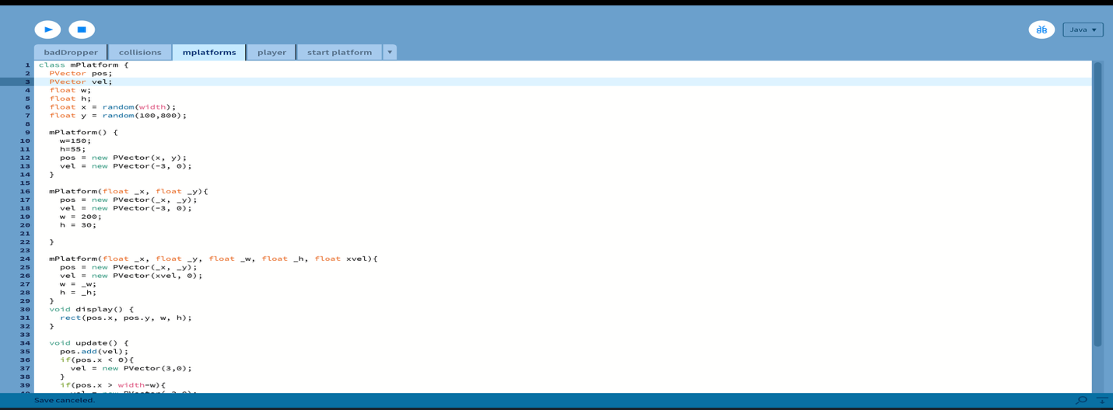
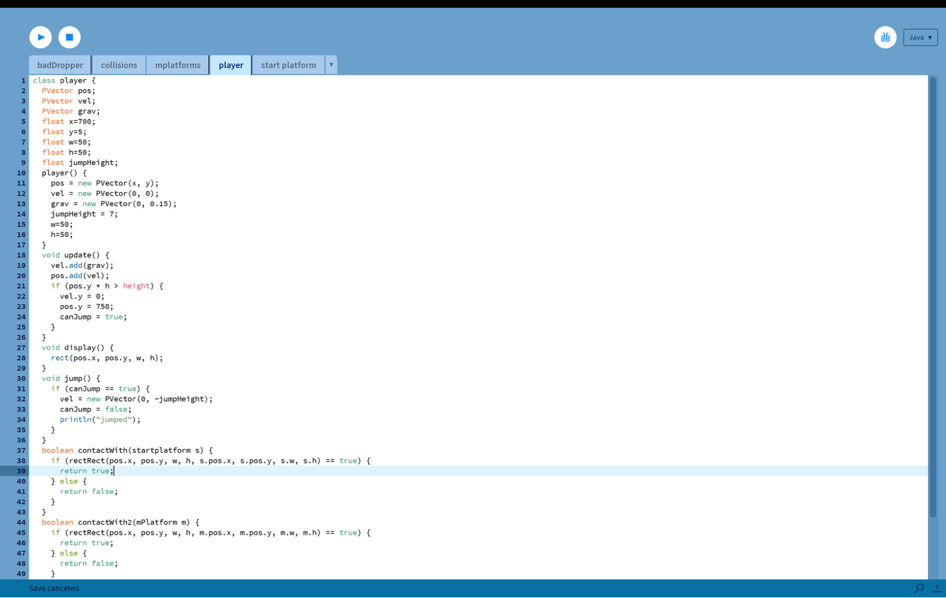

Goals for next class: Create a better collision code using lineRect or lineLine and a gameover screen if I have time

